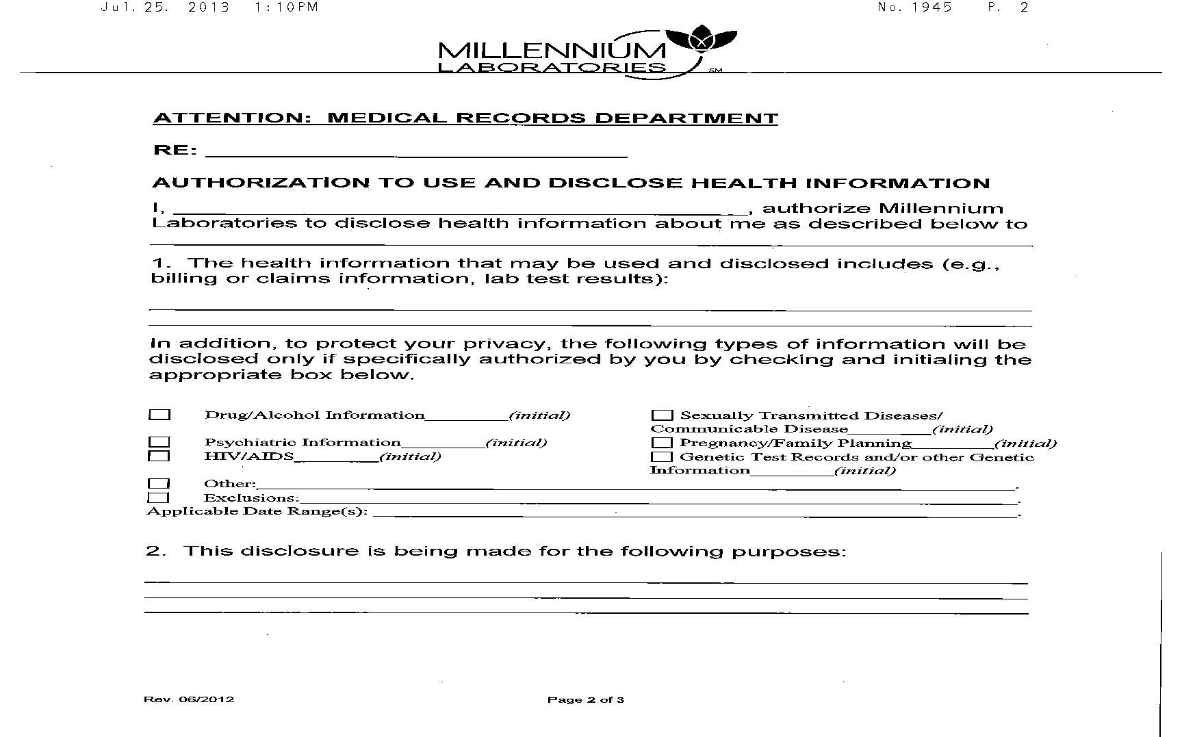

Release of Records
Batman
USE FOR WILLIAM DEARBAUGH:FROM 01/01/1979 TO PRESENT: Any and all MEDICAL RECORDS and FILMS (ON CD IF AVAILABLE). FROM TO PRESENT: BILLING RECORDS including but not limited to patient history form(s), and itemized write offs and billing payments, etc. pertaining to Batman SSN: xxx-xx-5555, DOB: 01/01/1979.
Litigation
Axiom Requisition Copy Service, 2869 Jolly Road Okemos, MI 48864
Order Number 01-29018-001
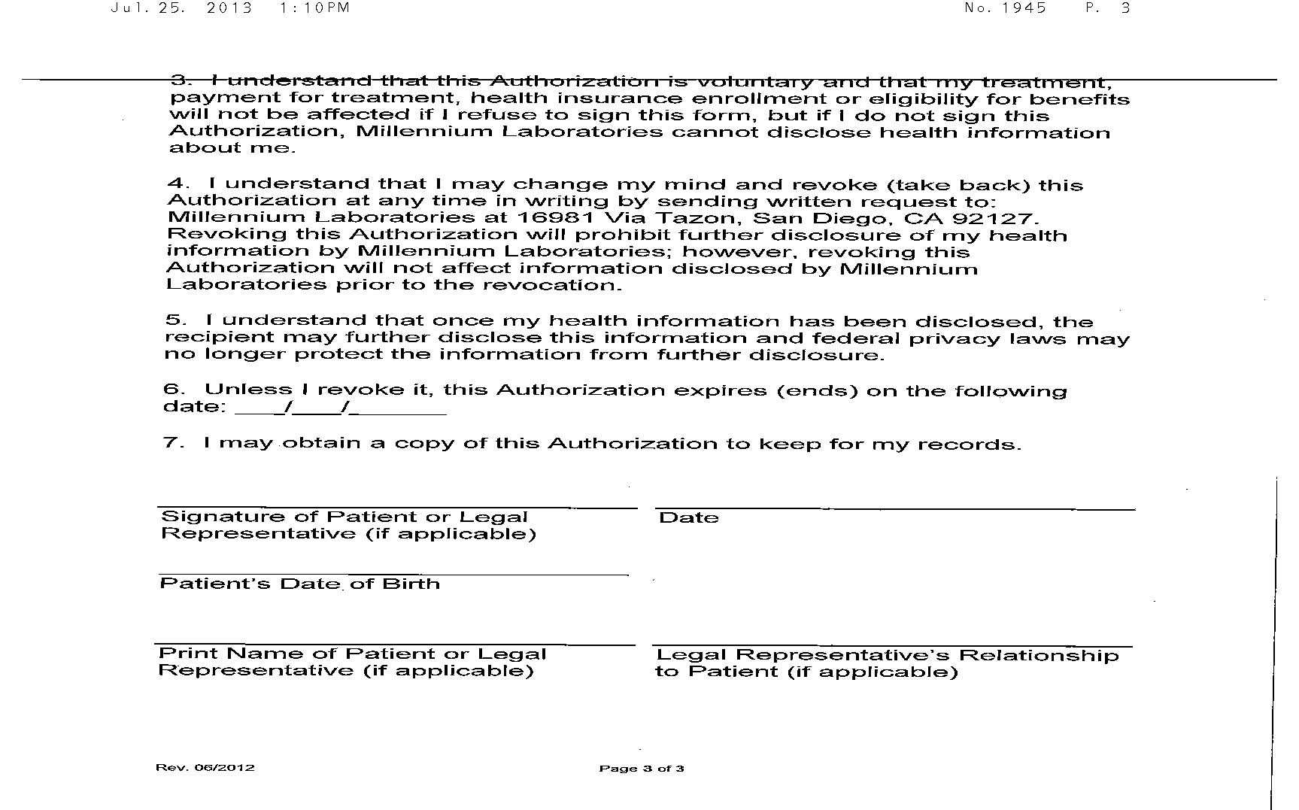
01/01/1979
Batman

Order Number 01-29018-001

